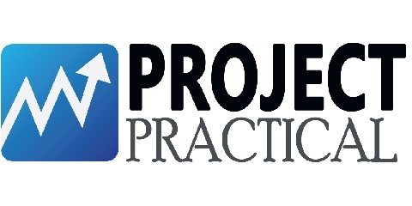

Organizational Process Assets
<Project Name>

Document ID | ORGANIZATIONAL PROCESS ASSETS-v0.1
Version Number | 0.1
Issue Date | April 01, 2020
Classification | Public

Copyright Notice
© COMPANYNAME, (original issue year – current issue year)

All Rights Reserved

The information contained in this document is the property of COMPANYNAME. No part of this document may be reproduced, stored in a retrieval system, or transmitted in any form, or by any means; mechanical, photocopying, recording, or otherwise, without the prior written consent of COMPANYNAME. Under the law, copying includes translating into another language or format. Legal action will be taken against any infringement.

The information contained in this document is subject to change without notice and does not carry any contractual obligation for COMPANYNAME. COMPANYNAME reserves the right to make changes to any products or services described in this document at any time without notice. COMPANYNAME shall not be held responsible for the direct or indirect consequences of the use of the information contained in this document.

Revision History
Date | Version | Description | Author (s)
04/01/2020 | 0.1 | Draft Version | John Doe

Reviewed By (Customer) | Signature | Date
The reviewer signoff shall signify the recommendation for acceptance of this document.

Sign Off

Prepared By | Acknowledged By
<Name> | <Name>
Title: <Position> | Title: <Position>
COMPANYNAME | COMPANYNAME
Date: | Date:

Accepted By | Accepted By
<Name> | <Name>
Title: <Position> | Title: <Position>
<Customer Company Name > | <Customer Company Name >
Date: | Date:

Table of Contents
List of Tables 6
List of Figures 7
1 Introduction 8
2 Description 8
Appendix 9

List of Tables
Table 1: Checklist 8

List of Figures

Introduction
The purpose of gathering organizational process assets from the enterprise is to ensure that current standards in use are continued throughout any new initiatives and any governance standards used are continued into the development of a new solution.

Description
Organizational process assets include the elements of existing business analysis approaches in use by the organization. Organizational process assets that may be useful in defining the business analysis approach include methodologies for process change or software development, tools or techniques that are in use or understood by stakeholders, corporate governance standards (such as COBIT™, Sarbanes-Oxley, and Basel II), and templates for deliverables. In addition to these general standards, the organization may have guidelines in place for tailoring the process to fit a specific initiative. The following table is a checklist to use to gather the information at the beginning of a project to ensure current standards are followed.

Asset Type | Description | Still In Use | Location
Process Change Methodology
Software Development Methodology
Software Development Tools
BA Technique | (those known to be understood)
BA Technique
Corporate Governance
Template
Template
Template
Table 1: Checklist

Appendix

